This is a checklist of basic organizational functions to keep in mind while managing the current crisis. It is by no means exhaustive, but meant to ensure your organization is covering the basic functions.

- Governance
  - Board
    - Notify and keep updated of steps taken, request support needed
  - Committees
    - Notify and keep updated of steps taken, request support needed
  - Leadership
    - Activate organization continuity plan
    - If you don't have one - good resources here: https://www.ready.gov/business-continuity-plan
- Funders
  - Near term fundraisers, meetings, or cancellations
  - Staff relationships / CRM
    - Is the CRM contact info available to staff remotely?
  - Manage donor, grantor, government, etc relationships
    - Review agreements – is there a way to extend terms and other requirements
    - Review reporting deadlines
    - Review funding and use restrictions – Can the grant be converted to unrestricted?
- Finance and Accounting
  - Basic Accounting and Payroll
    - Accounting system - Online and accessible?
      - Who has physical checks?
      - Who needs to sign them?
    - Legal documents and board book
      - Do we have copies of all our important documents on hand?
    - Payroll
      - Can payroll be processed remotely?
      - Do we have what we need to get our staff paid?
    - Taxes
      - What is our tax situation?
    - Debt
      - Who is our lender? What are the terms and conditions? Are we on an automatic debit payment system?
    - Banking
      - How is our bank operating now?
      - Do we have all our account information on hand?
    - Audit
      - Are we expecting to be preparing for our audit?
      - If so, lets convene the relevant parties to discuss

    - Operating expense
      - Rent
      - Utilities
      - Payroll
      - Other fixed or pending expenses
      - How many days of operating cash on hand do we have once we skinny down, as needed?
  - Financial Projections
    - Revenue shocks
    - Expense shocks
    - Project cashflow
    - Best case, worst case, most likely case – Ask board for input
      - Any issues or reasons for concern?
      - Do we have a cash crunch?
        - If yes, lets book a free one-on-one with CCA
        - Not sure, lets book at free one-on-one with CCA
  - Insurance
    - Collect policy info; contact information for broker
    - Review policies
    - Any claims necessary?
    - NIAC – Nonprofit Insurance Alliance of California may be able to help
- HR and Staffing
  - Review Staff Contracts, if needed
  - HR Policies, update and review as needed
    - Keep updated with federal, state, and local policy changes
    - Workers Compensation
    - Sick leave policy
    - Bereavement policy
    - Reimbursement policy for use of personal infrastructure for work
    - Emergency staff loan or advances policy
    - Health insurance policy
  - Remote working equipment and resources
    - Does staff have the physical equipment to work from home?
    - Does staff have the organization data to work from home?
    - Does staff have the cloud software, calendaring, project management, and communication?
    - Who is picking up the mail?
  - Laying off staff, canceling contracts/contractors
    - Contractual limitations
    - Financial penalties
    - Reputational issues
    - Funding available to hold on to staff
      - SBA program potential

- Technology / IT
  - Removing working infrastructure
    - Webinars / Conference Call
      - Many free services available
    - Cloud Storage
      - Techsoup
    - Cloud Software
      - Google Nonprofits
      - Microsoft Nonprofits
      - Techsoup can offer support and guidance, certain amount of free resources available from the above
  - Security
    - Building security if unoccupied for long periods of time
    - Notify landlord, if applicable
    - Shutoff utilities
  - Review security procedures
    - Data and online security
    - Ensure all data and personal information is locked up
    - Ensure backups are made
    - Remind all staff to use appropriate online security and antivirus when working from home and when using personal computer/devices with organization data, if applicable
  - Backups
    - Have backup software for critical organization data
- Communications
  - Internal communications
    - Board and Committees
    - Staff
    - Contractors
    - Vendors
    - Volunteers
  - External communications
    - COVID-19 responses
    - Website update
    - Newsletter or email update to constituents
- Services
  - Ongoing Service Expectations
    - Funding requirements
    - Staffing requirements
    - Resourcing requirements
  - Changes in services requests from community
    - Needs assessment
    - Organize staff
    - Mobilize donors
    - Mobilize volunteers

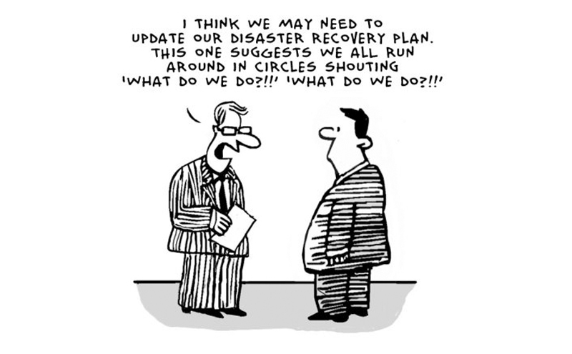

Silicon Valley Community Resources

Area Aggregated Response and Resources
- Silicon Valley Strong
- San Mateo County Strong
- Santa Clara County Public Heath COVID-19 News

Area Foundation Resources
- Silicon Valley Community Foundation
- Community Foundation San Benito County
- Community Foundation Santa Cruz County
- Community Foundation Sonoma County
- East Bay Community Foundation
- Marin Community Foundation
- Napa Valley Community Foundation
- San Francisco Foundation
- Solano Community Foundation

Government Resources
Overview of the CARES Act – Key provisions related to nonprofits
www.councilofnonprofits.org/trends-policy-issues/initial-analysis-of-the-coronavirus-aid-relief-and-economic-security-act-cares

Federal Loan Programs Available to Nonprofits
www.councilofnonprofits.org/trends-policy-issues/loans-available-nonprofits-the-cares-act-public-law-116-132

Overview of State and Local Government Resources in California
www.ibank.ca.gov

For more information on:
Community Capital Advisors (www.communitycapitaladvisors.us)
American Nonprofits (www.americannonprofits.org)

